Prepared for | AnalystLab Africa, Data Analytics Internship
Prepared by | Theresa Onyegiri
Role | Junior Business Intelligence Analyst
Track Collaboration | Data Science
Collaborated with | Zamokuhle Maseko
Project | HealthConnect Clinic Experience Lab
Week | Week 7
Project Title | Improving Patient Appointment Attendance and Healthcare Support Using Data and AI
Tool | Python, Predictive Model
Dataset | HealthConnect_Appointment_Data
Data Science
Data Science

CROSS-TRACK COLLABORATION SUMMARY
Collaboration Overview
During Week 7, we transitioned the HealthConnect No-Show Prediction Model from a Jupyter Notebook environment into an interactive, web-hosted Flask interface. The objective was to validate model accuracy, ensure user input persistence, and establish an automated audit logging pipeline for downstream communication workflows.
Cross-Track Engagements:
Communication was done via Slack and email and all relevant input, observations, updates and files were shared to achieve an improved and functional predictive model for HealthConnect.
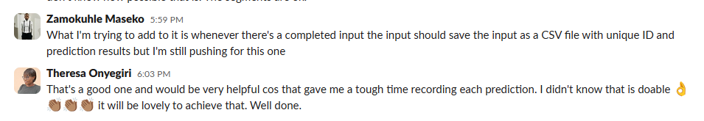
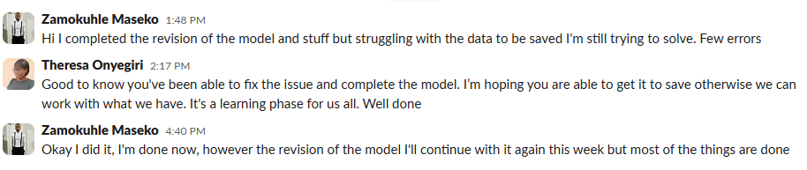

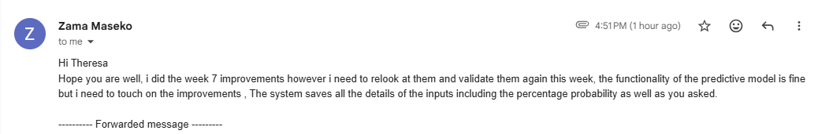

Testing, Findings & Model Refinements
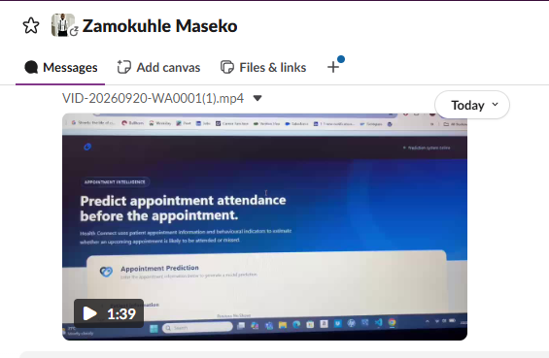
Validation Result:
- The model was successfully accessed with live browser using anaconda prompt and Flask.
- Input parameters remain populated on-screen, post-prediction for clinical verification.
- Continuous write-to-file verified. Each prediction automatically generates a log entry in csv file.
- Real-Time Prediction: User enters patient parameters (e.g., Age, Lead Time, SMS Received, Prior No-Shows). The model outputs both predictions (Likely No-Show and Likely to Attend) and the probability displays the score on-screen.

